**Train Model - Defect Report**

**Tanvi Verma**

| **Bug: Train displaying negative velocity** | | |
| --- | --- | --- |
| **Overview** | Description | The train model UI would display negative velocity values and the train would start traveling in reverse direction. |
| Defect Type | Bug |
| Reported By | Tanvi Verma, Lauren Gilfillan |
| Date Reported | 4/7/2024 |
| **Details** | Branch | Tanvi’s-branch |
| Severity | High |
| Priority | High |
| Complexity | Medium |
| Assigned To | Tanvi Verma |
| Steps to Reproduce | 1. Dispatch a train to a far enough station (Ex: Pioneer) |
| Observed Response | The train would start with negative acceleration and authority wouldn't decrease at all. Once the service brakes are hit by the train controller, the velocity would decrease and the train would stop at a negative velocity. |
| **Conclusion** | Status | Resolved |
| Notes | This bug existed when we were trying to produce friction in the system and also because the actual velocity method did not have a condition to deal with negative velocity. These issues were resolved and the train controller added a feature where the train is instantiated with the service brakes activated. |
| Resolved By | Tanvi Verma |
| Date Resolved | 4/20/2024 |

**Verification:**

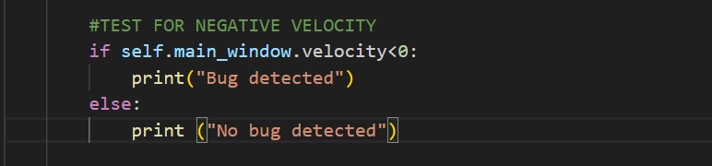

**Results:**

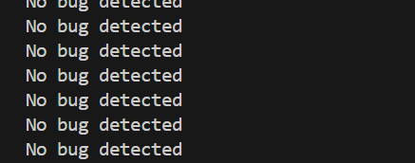

| **Bug: Acceleration value would increase unrealistically fast** | | |
| --- | --- | --- |
| **Overview** | Description | The acceleration value would increase exponentially fast once the train was dispatched. |
| Defect Type | Bug |
| Reported By | Lauren Gilfillan, Chad Collina |
| Date Reported | 4/11/24 |
| **Details** | Branch | Tanvi’s-branch |
| Severity | Medium |
| Priority | Medium |
| Complexity | High |
| Assigned To | Tanvi Verma |
| Steps to Reproduce | 1. Dispatch a train to a far enough station (Ex: Pioneer) 2. Observe acceleration values at 1x speed. |
| Observed Response | As a train would be dispatched, the acceleration display would jump and the actual velocity would reach max speed within an instance. This opposed natural behavior and Newtonian laws. |
| **Conclusion** | Status | Resolved |
| Notes | The acceleration calculation was not using the delta time and was using real time instead. |
| Resolved By | Tanvi Verma |
| Data Resolved | 4/13/2024 |

| **Bug: Emergency break affected the acceleration display on the UI.** | | |
| --- | --- | --- |
| **Overview** | Description | Enabling the emergency brake on the train model UI would affect the acceleration lcd display and display random numbers. |
| Defect Type | Bug |
| Reported By | Tanvi Verma |
| Date Reported | 4/22/24 |
| **Details** | Branch | Tanvi’s-branch |
| Severity | High |
| Priority | High |
| Complexity |  |
| Assigned To | Tanvi Verma |
| Steps to Reproduce | 1. Dispatch a train to a far enough station (Ex: Pioneer) 2. Enable emergency brakes. 3. Observe acceleration values at 1x speed. |
| Observed Response |  |
| **Conclusion** | Status | Unresolved |
| Notes |  |
| Resolved By |  |
| Data Resolved |  |